# Mohanad Mohamed Abdelmonem Eissa

# Lab 3

## Building project using Makefile

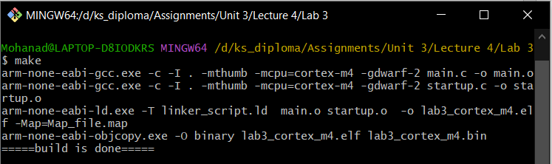

## A screenshot of a computer Description automatically generatedDebugging on Keil using simulator

## Debugging on Keil using TivaC board and Stellaris ICDI

